**DATA STRUCTURE GROUP ASSIGEMENT**

Group members

|  |  |
| --- | --- |
| **Student Name** | **Student Number** |
| Haipinge T.N.P | 221116699 |
| Morning J Nekongo | 221070044 |
| Uugulu Nathanael Fide | 222055030 |
| Hafeni Ndeunyema | 221072101 |
| Roswitha Kamahya | 222133279 |
| Daniel Namolo | 222133538 |
| Nangudi Paulus S | 222023805 |

**SECTION A**

Pseudo code

initialize music player

initialize playlist

initialize tracklist

initialize repeat function

initialize search function

initialize add/remove function

play music player

play tracks from playlist

repeat tracks as necessary

search for specific tracks

add/remove tracks as necessary

exit

end

**Algorithm**

function create_playlist()

tracks := 100

linked_list := create_new_linked_list()

for i := 0 to tracks-1 do

add_track(linked_list, i)

end for

return linked_list

end function

function play_track(linked_list, track_number)

current_track := linked_list.head

for i := 0 to track_number-1 do

current_track := current_track.next

end for

play_audio(current_track.data)

end function

function add_track(linked_list, track_number)

new_track := create_new_track(track_number)

if linked_list.head = null then

linked_list.head := new_track

else

current_track := linked_list.head

while current_track.next != null do

current_track := current_track.next

end while

current_track.next := new_track

end if

end function

function remove_track(linked_list, track_number)

current_track := linked_list.head

previous_track := null

for i := 0 to track_number-1 do

previous_track := current_track

current_track := current_track.next

end for

if previous_track = null then

linked_list.head := current_track.next

else

previous_track.next := current_track.next

end if

end function

function search_playlist(linked_list, track_number)

current_track := linked_list.head

while current_track != null do

if current_track.data = track_number then

return true

end if

current_track := current_track.next

end while

return false

end function

**FLOWCHART**

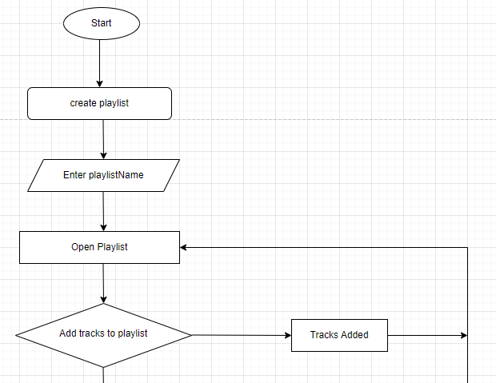

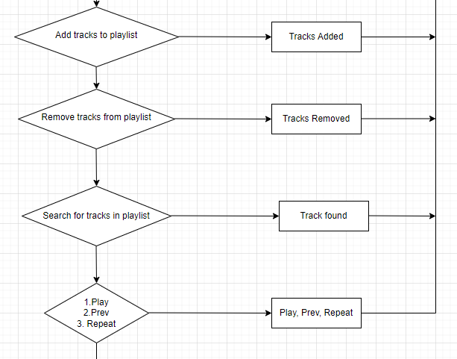

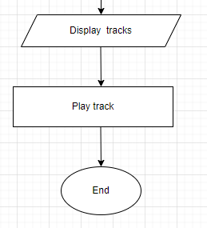

**SECTION B**

public class musicPlayer {

public static void main(String[] args) {

}

public final class DoubleClass<Music> {

private Music data;

private DoubleClass<Music> next;

private DoubleClass<Music> prev;

public DoubleClass(final DoubleClass<Music> prev, final Music data, final DoubleClass<Music> next) {

this.data = data;

this.next = next;

this.prev = prev;

}

public DoubleClass(final Music data) {

this(null, data, null);

}

public Music getData() {

return data;

}

public DoubleClass<Music> getNext() {

return next;

}

public void setTheNextTrack(final DoubleClass<Music> next) {

this.next = next;

}

public void setThePreviousTrack(final DoubleClass<Music> prev) {

this.prev = prev;

}

public DoubleClass<Music> getPrev() {

return prev;

}

public void addTracks(final Music data) {

this.data = data;

}

}

}